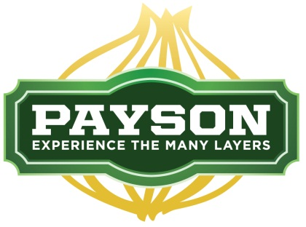

Items to be discussed at City Council Work Session, July 30, 2014.

1. Theme for Main Street
2. One Way or Two Way Street
3. Beautification ideas if Main Street remains a one-way street
4. Removal of existing trees (27-30) including a cross section of Utah Avenue
5. Raised Planter Boxes for trees and flowers
6. Irrigation System
7. Types of Trees
8. Tree rotation program (when trees become too big, transfer them to other areas of city)
9. Sidewalk Safety and aesthetics
10. Benches and sitting areas
11. Other

