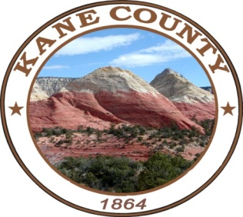
NOTICE AND AGENDA OF A MEETING OF THE KANE COUNTY COMMISSION
***************************************

PUBLIC NOTICE IS HEREBY GIVEN that the Commissioners of Kane County, State of Utah, will hold a Commission Meeting in the Commission Chambers at the Kane County Courthouse, 76 N. Main Street, Kanab, Utah on Tuesday, April 9, 2024 at the hour of 2:00 P.M.

*The Commission Chair, in her discretion, may accept public comment on any listed agenda item unless more notice is required by the Open and Public Meetings Act.

This meeting is available for call in option - #435-676-9000 – Enter participant code- 168030

CALL MEETING TO ORDER
WELCOME
INVOCATION
PLEDGE OF ALLEGIANCE

PUBLIC COMMENT:

CONSENT AGENDA:

Check Edit Report:
Approval of: Commission Meeting Minutes for March 26, 2024 and Kane County Resolution No. R 2024-14 a Resolution Recognizing Sexual Assault Awareness Month

REGULAR SESSION:

- Public Hearing Regarding the Appointment of Cameron Westenskow and Jesse Pennepacker to the Church Wells Special Service District Administrative Control Board

- Kane County Resolution No. R 2024-12 a Resolution Appointing Cameron Westenskow to the Church Wells Special Service District Administrative Control Board/Commissioner Kubeja

- Kane County Resolution No. R 2024-13 a Resolution Appointing Jesse Pennepacker to the Church Wells Special Service District Administrative Control Board/Commissioner Kubeja

- Kane County Ordinance No. O 2024-13 an Ordinance Establishing County Policy Regarding Public Acknowledgment of the Use of County Funds/Full Commission

- Discussion/Approval of TRT Fund Expenditures/Full Commission

- Old Elementary School Discussion/Full Commission

- Review of Legislative Issues/Full Commission

- Commissioner Report on Assignments/Full Commission

Closed Session:

- Discussing an individual’s character, professional competence, or physical or mental health.
- Strategy sessions to discuss collective bargaining, pending or reasonably imminent litigation, or the purchase, exchange lease or sale of real property.
- Discussions regarding security personnel, devices or systems.
- Investigative proceedings regarding allegations of criminal misconduct.

NOTICE OF SPECIAL ACCOMMODATION DURING PUBLIC MEETINGS:
In compliance with the Americans with Disabilities Act, individuals needing special accommodations (including auxiliary communicative aids and services) during this meeting should notify Chameill Lamb at (435) 644-2458. Agenda items may be accelerated or taken out of order without notice as the Administration deems appropriate. All items to be placed on the agenda must be submitted to the Clerk’s office by noon Thursday, prior to the meeting.

