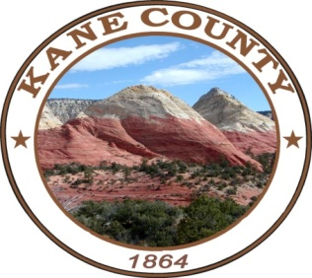
NOTICE AND AGENDA OF A MEETING OF THE KANE COUNTY COMMISSION
***************************************

PUBLIC NOTICE IS HEREBY GIVEN that the Commissioners of Kane County, State of Utah, will hold a Commission Meeting in the Commission Chambers at the Kane County Courthouse, 76 N. Main Street, Kanab, Utah on Tuesday, March 12, 2024 at the hour of 2:00 P.M.

*The Commission Chair, in her discretion, may accept public comment on any listed agenda item unless more notice is required by the Open and Public Meetings Act.

This meeting is available for call in option - #435-676-9000 – Enter participant code- 168030

CALL MEETING TO ORDER
WELCOME
INVOCATION
PLEDGE OF ALLEGIANCE

PUBLIC COMMENT:

CONSENT AGENDA:

Check Edit Report:
Approval of: Commission Meeting Minutes for February 27, 2024

REGULAR SESSION:

- Canvas of the March 5, 2024 Presidential Primary-Heather Narramore/Commissioner Heaton

- Payment In Lieu of Taxes (PILT) Payment Presentation by Utah Division of Wildlife/Commissioner Meyeres

- Recognition of Outgoing SSD Board Members/Full Commission

- Action on Rural County Grant Funds Recommended by the Kane County Economic Opportunity Board/Commissioner Meyeres

- Southwest Tech is Requesting a Total of $29,000 for Spring and Fall Course Business Development Training Offerings in 2024

- Kanab Area Chamber of Commerce Requests $10,000 for Business Development and Expansion, General Support, as well as Workforce Training and Development

- Discussion/Possible Action Regarding the Willow Reserve Public Infrastructure District (PID) No. 1/Full Commission

- Review of Legislative Issues/Full Commission

- Commissioner Report on Assignments/Full Commission

Closed Session:

- Discussing an individual’s character, professional competence, or physical or mental health.
- Strategy sessions to discuss collective bargaining, pending or reasonably imminent litigation, or the purchase, exchange lease or sale of real property.
- Discussions regarding security personnel, devices or systems.
- Investigative proceedings regarding allegations of criminal misconduct.

NOTICE OF SPECIAL ACCOMMODATION DURING PUBLIC MEETINGS:
In compliance with the Americans with Disabilities Act, individuals needing special accommodations (including auxiliary communicative aids and services) during this meeting should notify Chameill Lamb at (435) 644-2458. Agenda items may be accelerated or taken out of order without notice as the Administration deems appropriate. All items to be placed on the agenda must be submitted to the Clerk’s office by noon Thursday, prior to the meeting.

