NOTICE OF PUBLIC HEARING

REQUEST To hear public comment regarding creation of a Planned Unit Development (Subdivision) for the project know as Towns at 400, containing 8 townhomes. The project is located at approximately 40 W 400 S, located in the Downtown (DN) Zone.

CONTACT Lloyd Cheney, City Engineer ph: 801-298-6125, or email at lloyd@bountiful.gov
Amber Corbridge, Senior Planner, 801-298-6190, or email at amber@bountiful.gov

DATE/TIME AND PLACE
The Bountiful Planning Commission will hold a public hearing for this item on Tuesday, March 19, 2024. The public hearing will start at approximately 6:30 pm in the Bountiful City Council Chambers, 795 South Main Street, Bountiful, Utah.

COMMENT Any person having interest in these matters may attend and be heard during a public meeting or may submit testimony in writing to be entered into the record.

LAND USE AUTHORITY
Planning Commission

NOTICING COMPLETED:

CERTIFIED (NOTICED) BY:

March 5, 2024

/s/Lloyd Cheney
Lloyd Cheney, City Engineer

LOCATION OF PROPOSED 8 UNIT TOWNS AT 400 PLANNED UNIT DEVELOPMENT

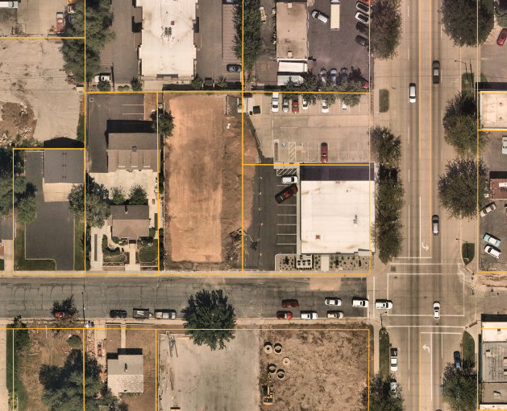
PROPOSED PLANNED UNIT DEVELPOMENT

