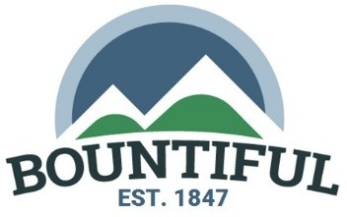

NOTICE OF PUBLIC HEARING

REQUEST To hear public comment regarding a Conditional Use Permit for Smoked Taco, a fast-food restaurant, at 245 W 500 S, located in the General Commercial (C-G) Zone.

CONTACT Amber Corbridge, Senior Planner, 801-298-6190 or email at amber@bountiful.gov

DATE/TIME AND PLACE
The Bountiful Planning Commission will hold a public hearing for this item on Tuesday, March 19, 2024. The public hearing will start at approximately 6:30 pm in the Bountiful City Council Chambers, 795 South Main Street, Bountiful, Utah.

COMMENT Any person having interest in these matters may attend and be heard during a public meeting or may submit testimony in writing to be entered into the record.

LAND USE AUTHORITY
Planning Commission

NOTICING COMPLETED:

CERTIFIED (NOTICED) BY:

March 4, 2024

/s/Amber Corbridge
Amber Corbridge, Senior Planner

LOCATION OF PROPOSED FAST-FOOD RESTAURANT

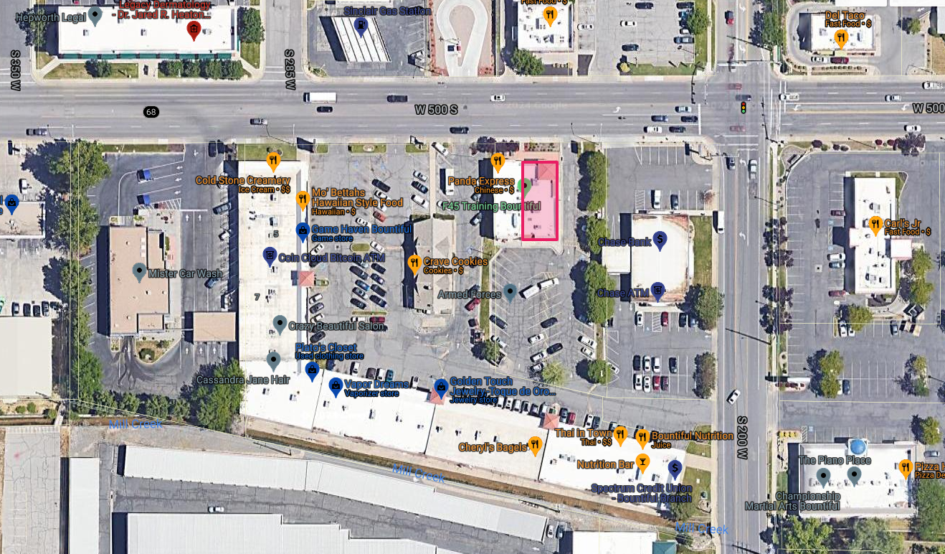
PROPOSED FAST FOOD RESTAURANT

