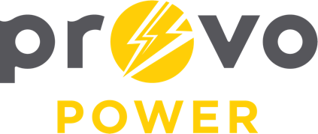
AGENDA
ENERGY BOARD MEETING
PROVO POWER
251 W 800 N
Monday, March 4, 2024
4:00 P.M.

- Welcome & Introductions – Chairman Gary Winterton
- Review & Approval of Minutes – February 5, 2024
- Financial Report – Charlie Little
- KPI Report – Charlie Little
- Manager Report – Travis Ball
- Calendar & Scheduling
  - UMPA Annual Meeting: March 20-22 (St. George)
  - April Board Meeting: cancelled
  - Next Board Meeting: May 6, 2024

A copy of the agenda was posted in the Civic Center, and the Provo City Library, on February 28, 2024, and also delivered to the Mayor,
City Council Members, required news media, and adjacent cities in
compliance with the Utah Code 52-4-202

