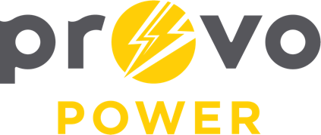
AGENDA
ENERGY BOARD MEETING
PROVO POWER
251 W 800 N
Monday, February 5, 2024
4:00 P.M.

- Welcome & Introductions – Vice-Chair Cheryl Taylor
- Review & Approval of Minutes – January 8, 2024
- Public Meeting Training – Matt Griffiths
- Financial Report – Charlie Little
- KPI Report – Charlie Little
- CIP Budget FY24 Review – Tad Smallcomb
- Manager Report – Travis Ball
- Calendar & Scheduling
  - Next Board Meeting: March 4, 2024

A copy of the agenda was posted in the Civic Center, and the Provo City Library, on February 1, 2024, and also delivered to the Mayor,
City Council Members, required news media, and adjacent cities in
compliance with the Utah Code 52-4-202

