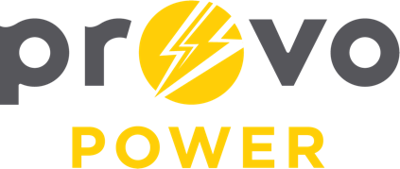
AGENDA
ENERGY BOARD MEETING
PROVO POWER
251 W 800 N
Monday, November 6, 2023
4:00 P.M.

- Welcome & Introductions - Chairman Gary Winterton
- Review & Approval of Minutes – October 2, 2023
- Financial Report – Charlie Little
- KPI Report – Charlie Little
- Forestry Report – Chaz Addis
- Manager Report – Travis Ball
- Calendar & Scheduling
  - Approve New Calendar

A copy of the agenda was posted in the Civic Center, and the Provo City Library, on November 1, 2023, and also delivered to the Mayor,
City Council Members, required news media, and adjacent cities in
compliance with the Utah Code 52-4-202

